James Liu

CS 4495, Computer Vision

Fall 2014

Problem Set 5

**Problem Set 6, Question 1, Part 1, Image 1**

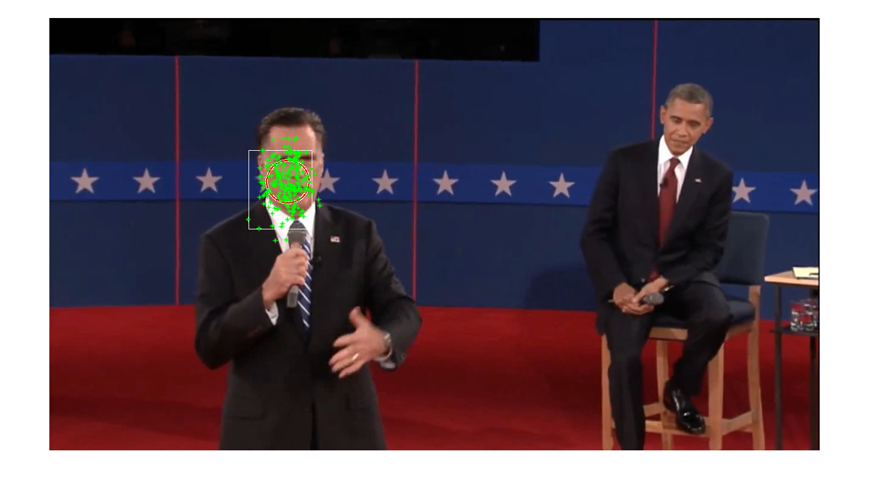

Frame 28 of pres_debate.avi while tracking Romney’s face, particles marked in green. White square is the best estimate of where his face is, and the distribution marked with the red circle.

**Problem Set 6, Question 1, Part 1, Image 2**

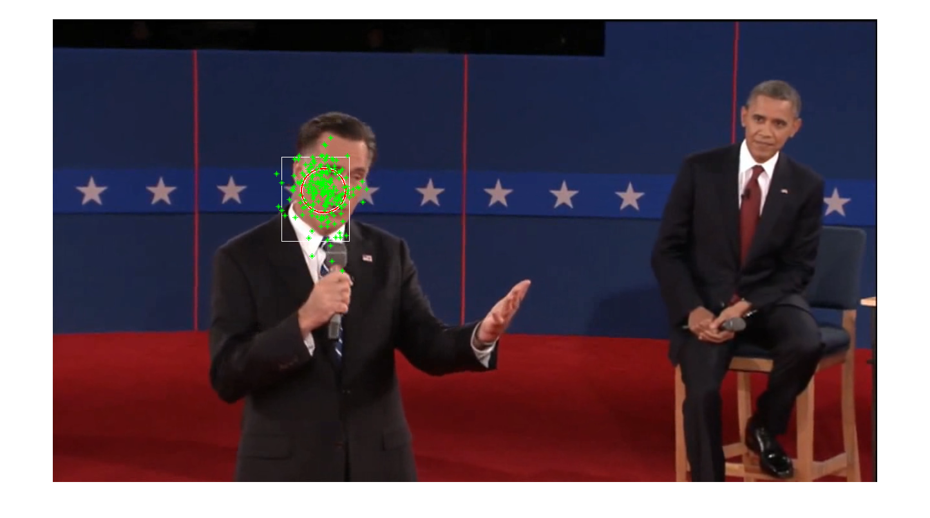

Frame 84 of pres_debate.avi while tracking Romney’s face, particles marked in green. White square is the best estimate of where his face is, and the distribution marked with the red circle.

**Problem Set 6, Question 1, Part 1, Image 3**

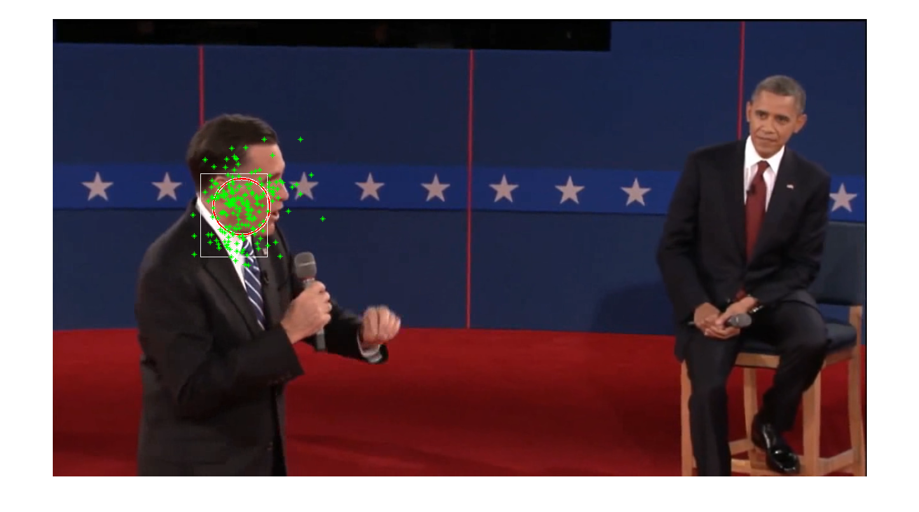

Frame 144 of pres_debate.avi while tracking Romney’s face, particles marked in green. White square is the best estimate of where his face is, and the distribution marked with the red circle.

**Problem Set 6, Question 1, Part 1, Image 4**

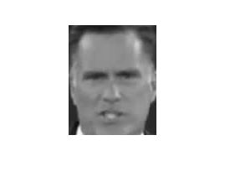

The image patch used for tracking.

**Problem Set 6, Question 1, Part 2**

Advantages to larger window size:

* Each individual pixel has a smaller impact on the resultant MSE and thus weight. To a degree, this will enforce less strict matching criteria than a smaller window, and thus converges slower than a smaller window, but also avoids converging to local optima.
* Also since each pixel has a smaller impact on the resultant MSE: a larger window is more robust to noise or distortion since the noise often averages out to a flat constant with the approximation of that noise becoming increasingly accurate with larger window sizes.

Advantages to smaller window size:

* Less computation, the amount of computation per frame increases linearly as the area of the window increases
* Each individual pixel has a larger impact on the resultant MSE and thus weight. To a degree, this will enforce more strict matching criteria than a larger window, and thus is converges faster, but is more prone to converging to local optima.

**Problem Set 6, Question 1, Part 3**

The sigma for the MSE Gaussian affects how the MSE value translates into the particle’s weight, and thus chance of being sampled in the next iteration. A high sigma results in a “fatter” Gaussian, and a low sigma results in a “skinny” Gaussian. Thus as sigma decreases, more weight is assigned to low error matches and the less weight assigned to high error matches. A low sigma would increase the chance of choosing a particle with a lower error. Thus a low sigma would lead to faster convergence due to much higher chances of sampling around the best few particles of the previous frame. This could also lead to convergence to local optima if the initial distribution isn’t well spread or too few particles are used.

**Problem Set 6, Question 1, Part 4**

The number of particles I found to be optimal for tracking Romney’s face was around 200. Any less and performance started deteriorating, and any more and it increased computation time for little benefit. A larger number of particles increases computation time per frame linearly, but also increases the accuracy to which it approximates the underlying distribution. If the number of particles were infinite, it would perfectly describe the underlying movement model. Because of this, more particles over a larger area allows the algorithm to avoid local minima by allowing it to examine an approximation of the global distribution and not just the local area.

**Problem Set 6, Question 1, Part 5, Image 1**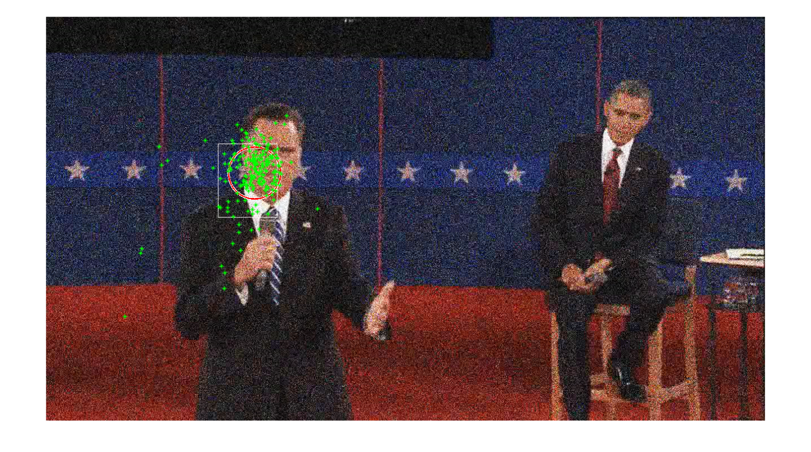

Frame 14 of noisy_debate.avi while tracking Romney’s face, particles marked in green. White square is the best estimate of where his face is, and the distribution marked with the red circle.

**Problem Set 6, Question 1, Part 5, Image 1**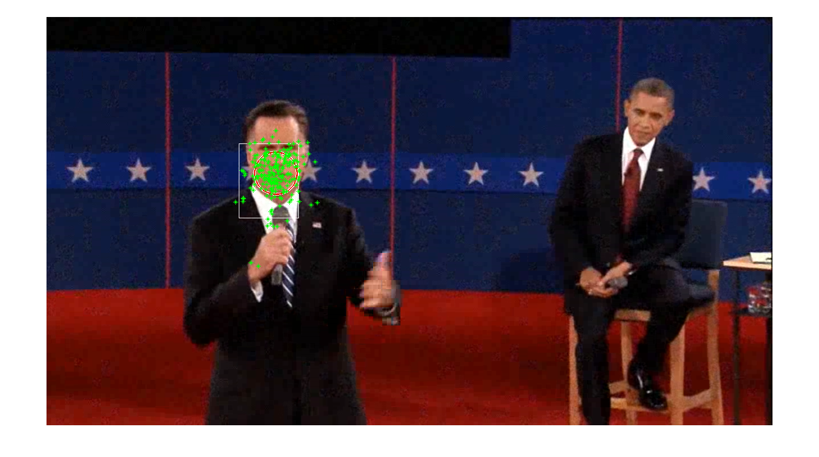 Frame 32 of noisy_debate.avi while tracking Romney’s face, particles marked in green. White square is the best estimate of where his face is, and the distribution marked with the red circle.

**Problem Set 6, Question 1, Part 5, Image 1**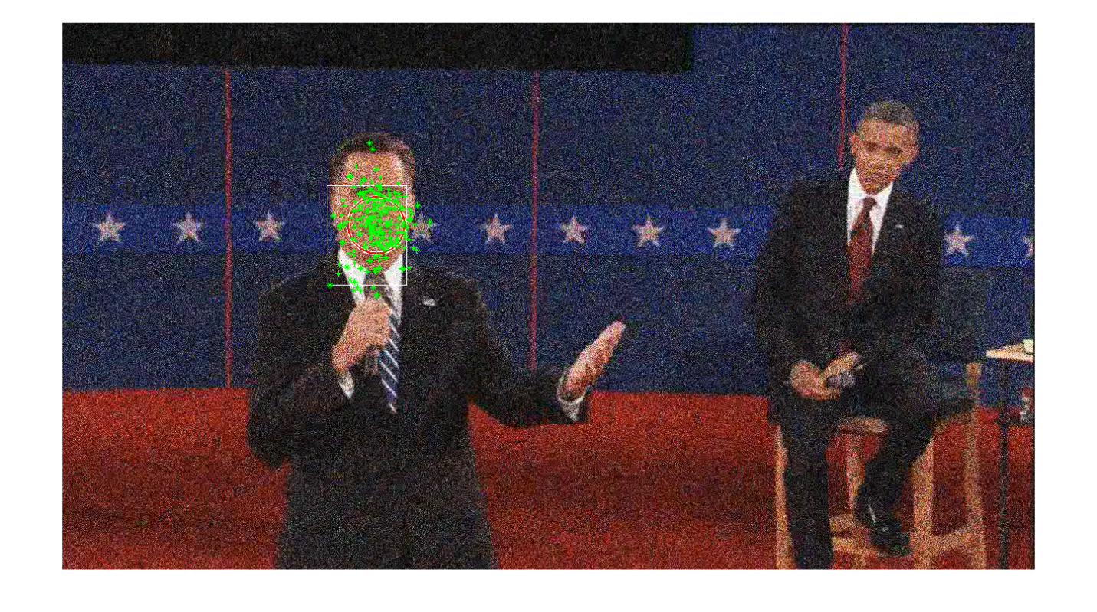 Frame 46 of noisy_debate.avi while tracking Romney’s face, particles marked in green. White square is the best estimate of where his face is, and the distribution marked with the red circle.

Increasing noise definitely disturbed the distribution of the particles. It made it harder for them to initially converge as the noise was also increasing. Decreasing noise made them converge back together again, as expected. I also found that the perturbations introduced by noise were reduced by increasing the window size, however increasing window size too much also caused it to not converge before the noise increased.

**Problem Set 6, Question 2, Part 1, Image 1**

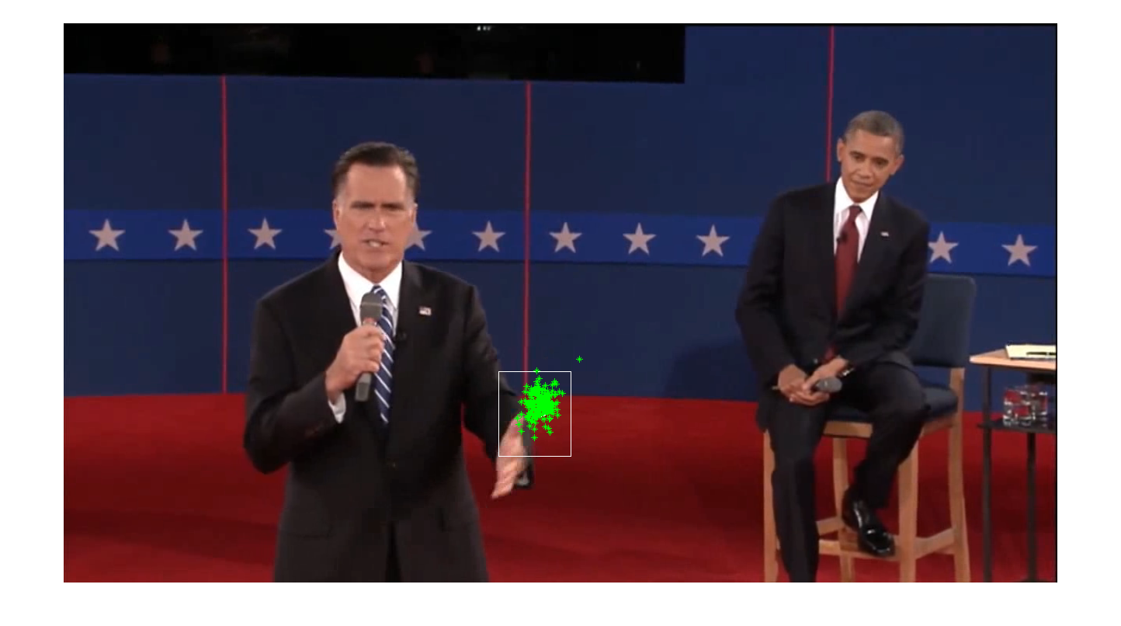

Frame 15 of pres_debate.avi while tracking Romney’s left hand, particles marked in green. White square is the best estimate of where his face is, and the distribution marked with the red circle.

**Problem Set 6, Question 2, Part 1, Image 2**

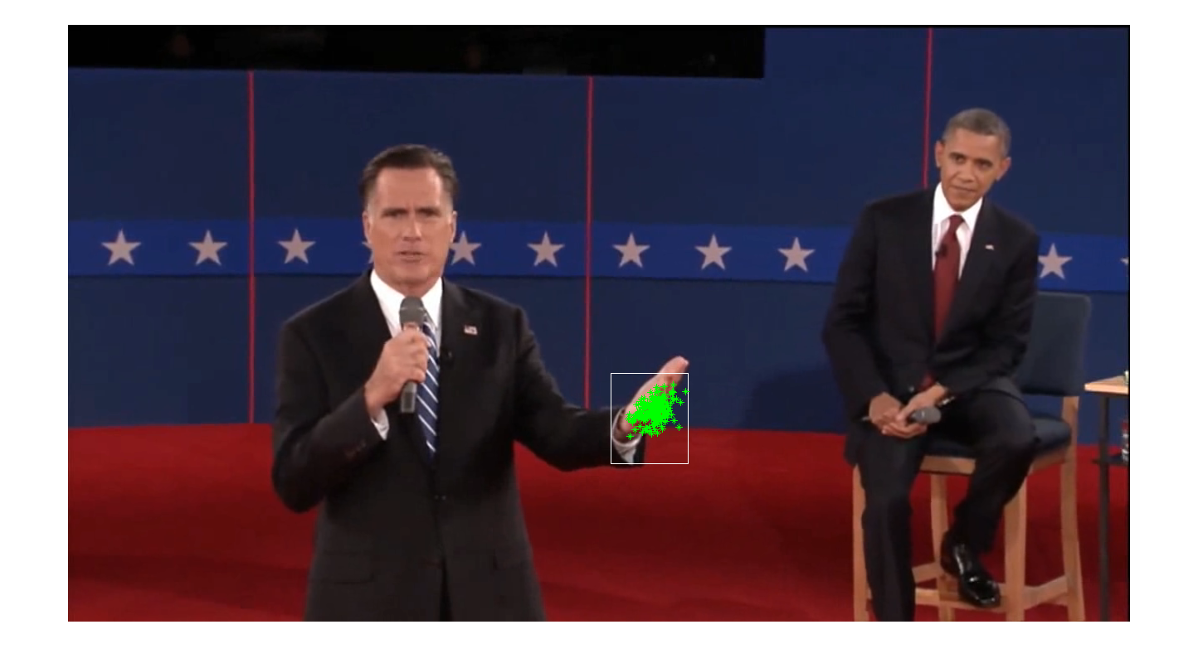

Frame 50 of pres_debate.avi while tracking Romney’s left hand, particles marked in green. White square is the best estimate of where his face is, and the distribution marked with the red circle.

**Problem Set 6, Question 2, Part 1, Image 3**

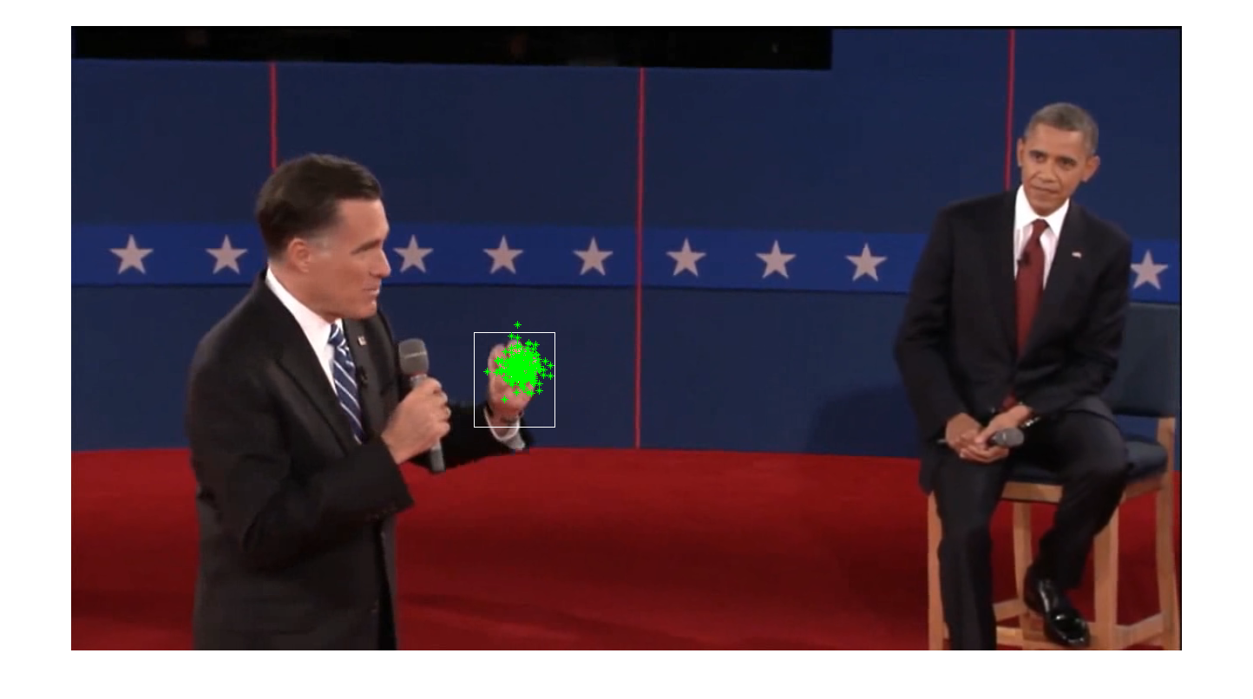

Frame 140 of pres_debate.avi while tracking Romney’s left hand, particles marked in green. White square is the best estimate of where his face is, and the distribution marked with the red circle.

**Problem Set 6, Question 2, Part 1, Image 4**

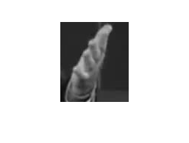

The initial image patch used to track Romney’s hand.

**Problem Set 6, Question 2, Part 2, Image 1**

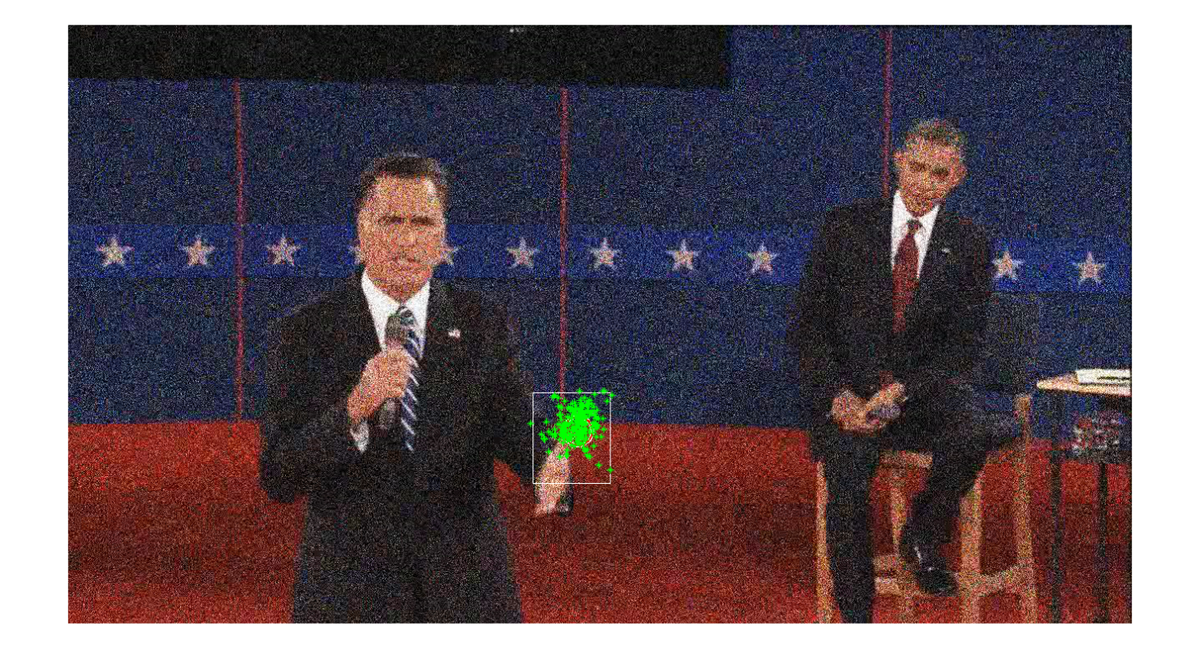Frame 15 of noisy_debate.avi while tracking Romney’s left hand, particles marked in green. White square is the best estimate of where his face is, and the distribution marked with the red circle.

**Problem Set 6, Question 2, Part 2, Image 1**

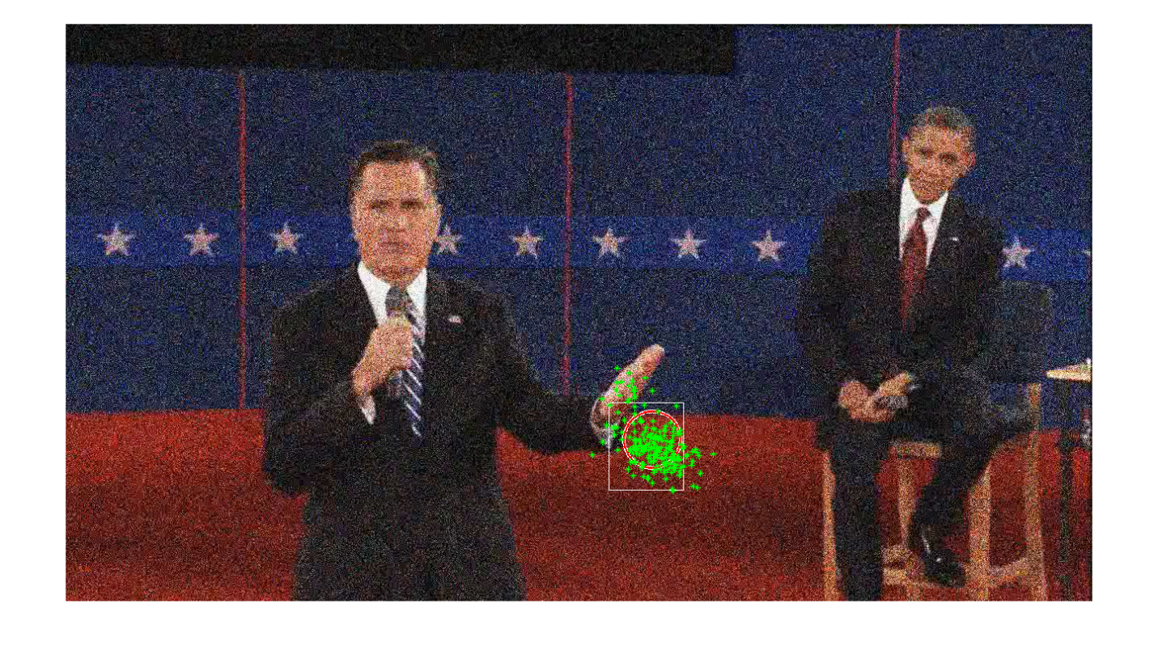Frame 50 of noisy_debate.avi while tracking Romney’s left hand, particles marked in green. White square is the best estimate of where his face is, and the distribution marked with the red circle.

**Problem Set 6, Question 2, Part 2, Image 1**

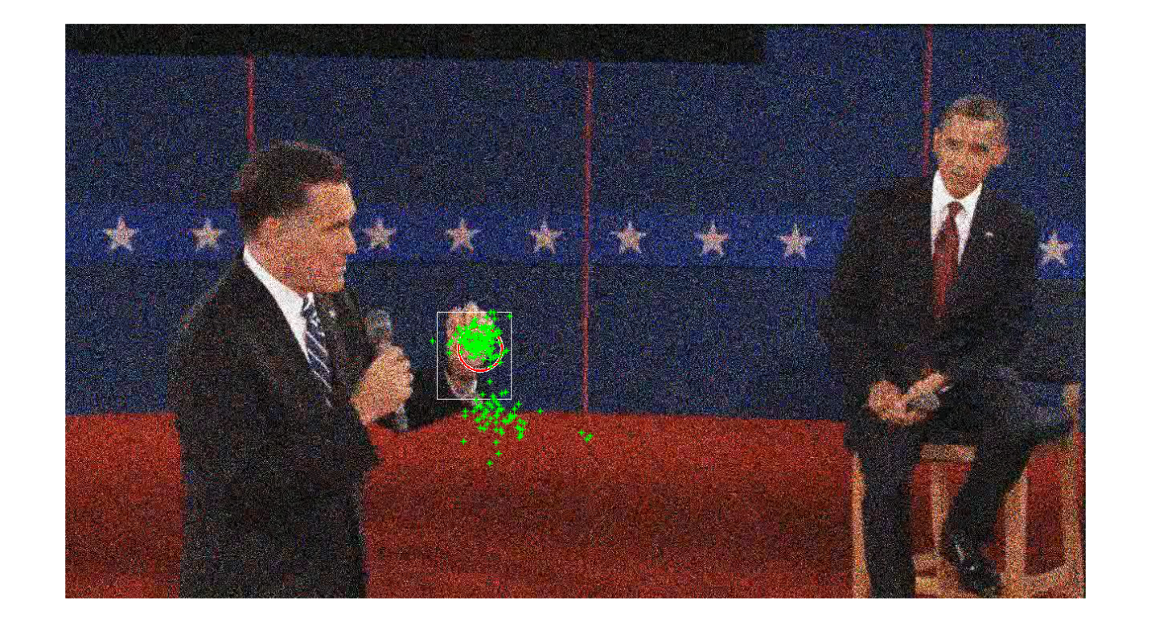Frame 140 of noisy_debate.avi while tracking Romney’s left hand, particles marked in green. White square is the best estimate of where his face is, and the distribution marked with the red circle.

**Problem Set 6, Question 2, Part 2, Image 1**

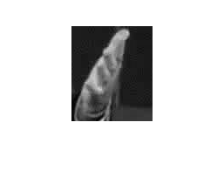

The initial image patch used to track Romney’s hand.

To get the hand tracking to work with the noisy video, I had increase the sigma for the MSE to let it be a bit more lenient so that noisy matches were not excluded. I tried increasing window size however that caused it to converge too slowly. I also tried decreasing alpha, but it then lost track of the hand altogether.